PROGRAM DESCRIPTION

Program gives user opportunity to control his own and family`s accounts virtual wallets which include bank accounts and cash. Users can create family groups for any group categories that means that they can have more than one family. Person, using this program, has opportunity to make any operations between his wallets and to wallets of family members, he can also view status of wallets of his families.

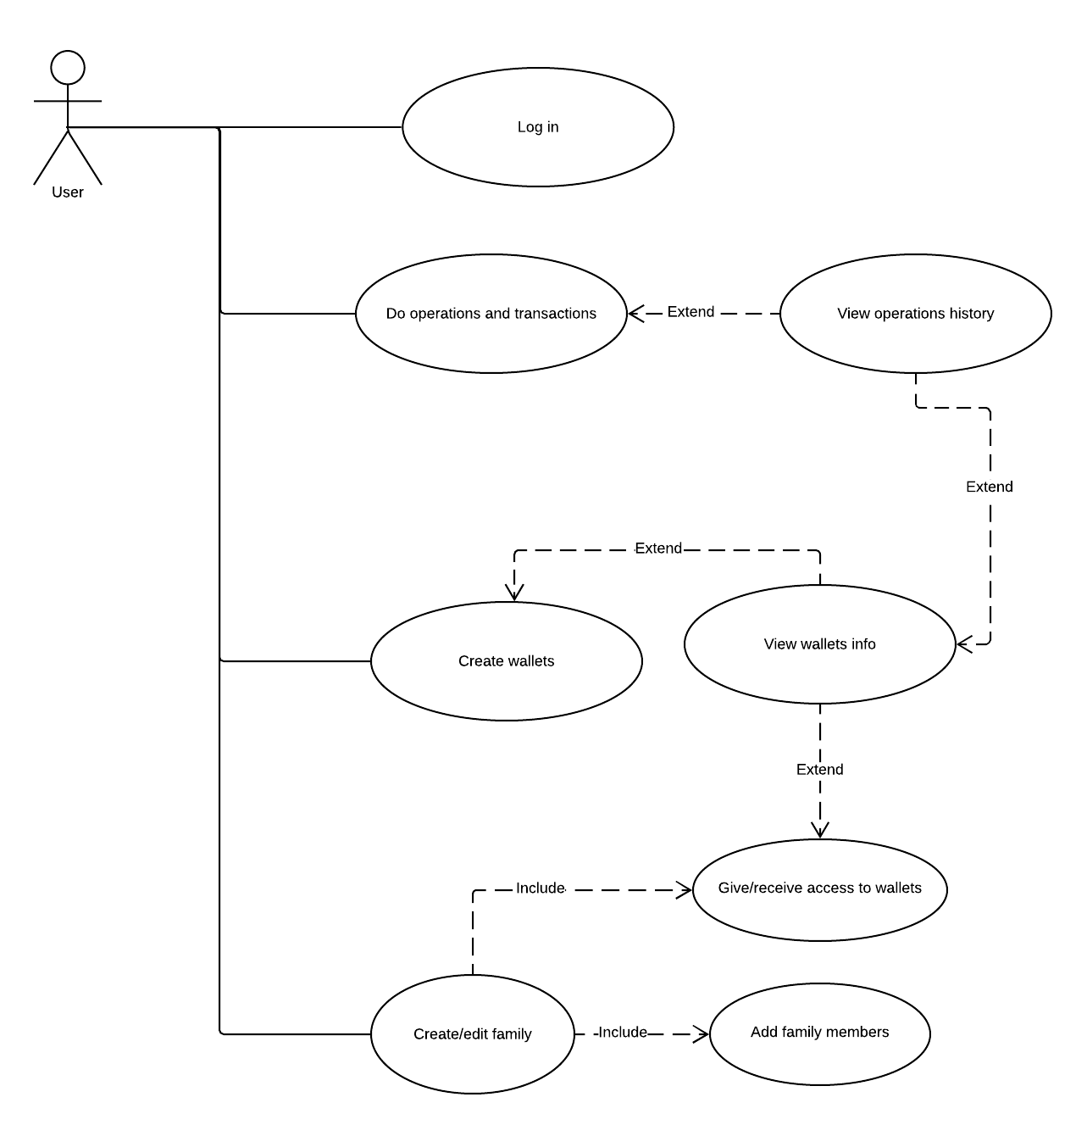

Image 1. Use Case diagram

To sign in user should use his account in social networks, for first time user should also enter his name. After signing in user can see his family groups and his own and family wallets. Program enables user doing operations with wallets to which he has access, operations variety depends on his access modifiers. User also can create new wallet or give access to his wallets to any other family members.

All operations will be stored so user will be able to see history of operations on his wallets. Also he will have ability to watch operations among on common family wallets.